APU Maintenance platform, 7m platform height, 4T payload

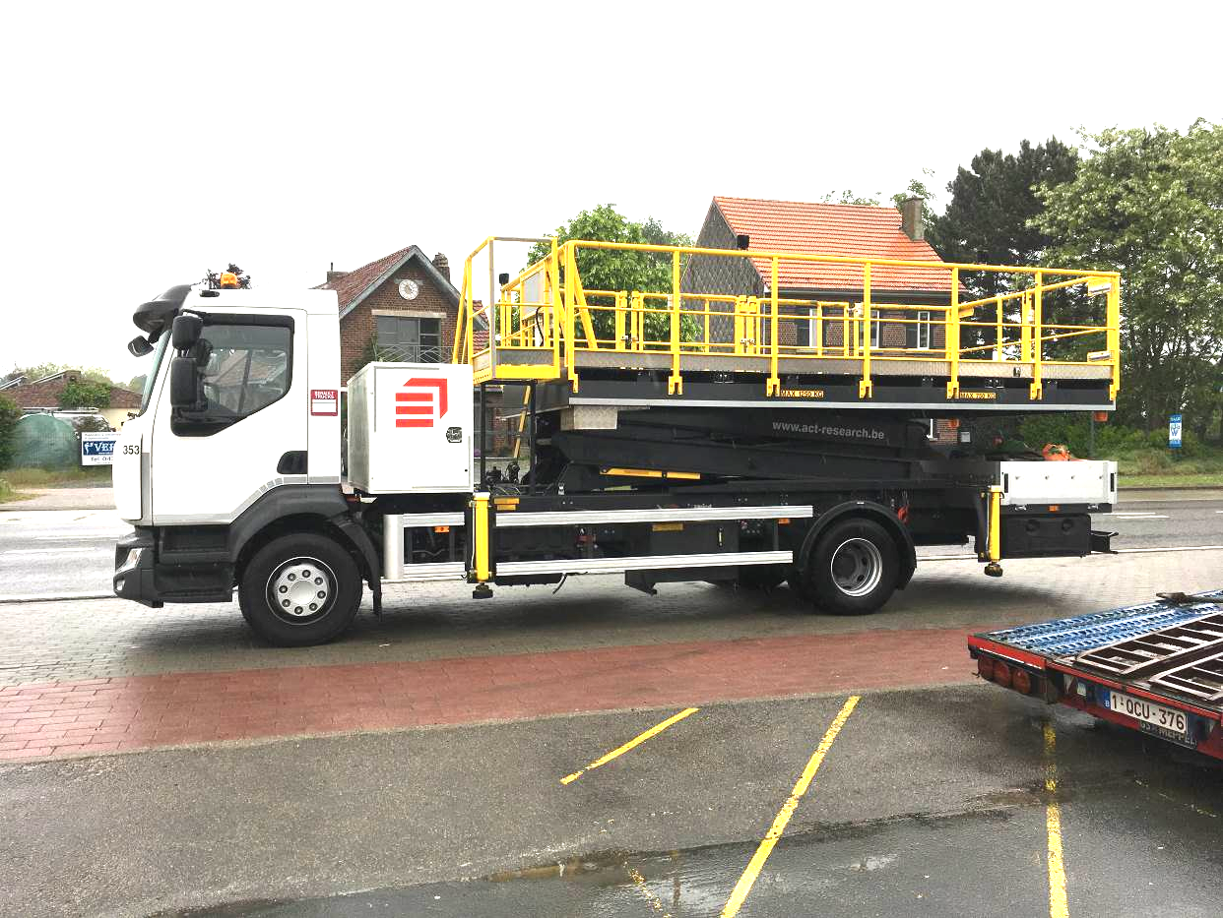

Specifications:

- Basic vehicle: Mercedes-Benz Atego 1518 wheelbase 4760 with PTO, Renault D 14T emp 4700 with PTO, or basic vehicle to customers choice
- Minimum platform floor height: 1 metre 85
- Maximum platform floor height: 7 metre 00
- Platform dimensions: 2 metre 50 x 5 metre 50
- Payload: 4 000 kg
- Vehicle width: 2 metre 60
- Vehicle length: 8 metre 70
- Hydraulic system with Rexroth components
- Electric and manual emergency pumps
- 4 stabilizers with synchronised movement
- Lowering rear end railings for APU repair- and maintenance-works
- Platform lightning by 4 adjustable lights
- The whole construction is painted in aero paint in order to get skydrol resistance
- Fixed entry stair at the front
- Starting and stopping of the engine via the switch box on the platform
- CE approved
- 2 year warranty on parts

Platform side extension:

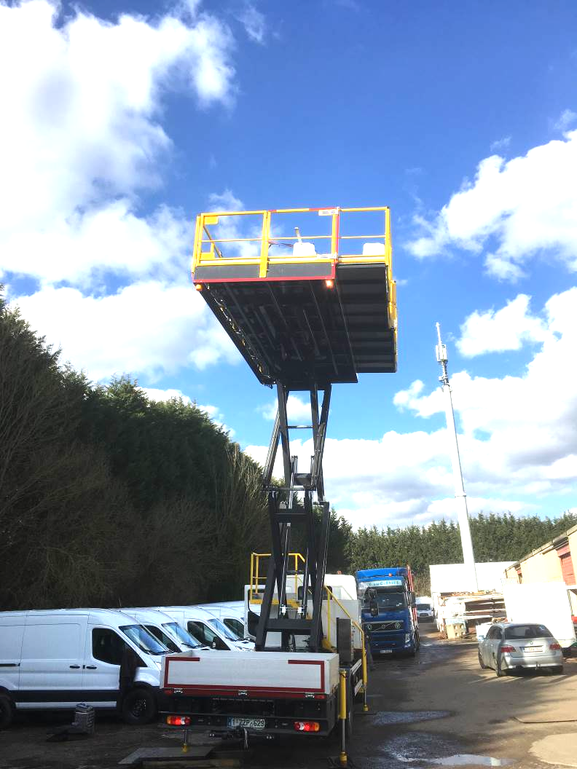

Options
- Hydraulic compressor
- 220 Volts inverter of 2500 Watt
- Construction to customer specification
- Forward moving Platform on top of cab if raised above cab height
- Optionally platform hydraulic side extension (wider platform RHS or LHS)
- Other options at customer demand
- 220 Volt supply to the platform with 220 Volt receiver plug at the bottom

